The new clarence function room business plan

Prepared by
The HULL COMMUNITY PUB SOCIETY LTD

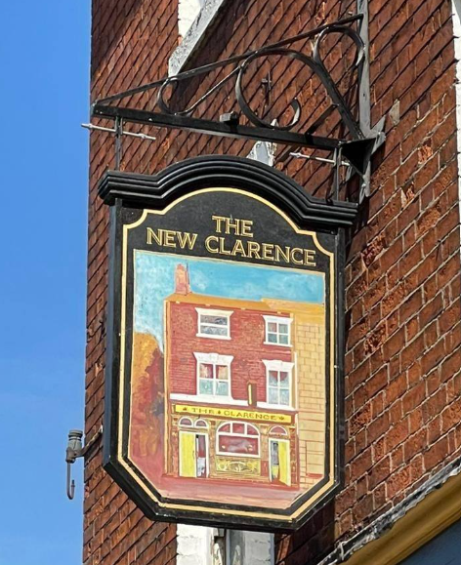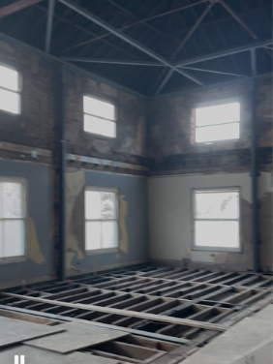

APRIL 2026
contents

1. BACKGROUND 3
2. OUR VISION 3
3. THE HULL COMMUNITY PUB SOCIETY LIMITED 4
4. THE MANAGEMENT COMMITTEE 6
5. OVERVIEW OF THE PROJECT AND FUNDING 7
6. COMMUNTIY ENGAGEMENT 11
7. MARKET RESEARCH 13
8. THE BUSINESS PLAN FOR THE FUNCTION ROOM 16
9. THE CAPITAL PLAN 19
10. Financial Forecasts 21
11. key risks and mitigations 24

BACKGROUND

The New Clarence closed in June 2023 and the back of house facilities were ripped out by the owner. A group of regulars got together to have the building designated as an Asset of Community Value and raised the funds required to buy back and renovate the pub. The group formed the Hull Community Pub Society in January 2024 and now owns The New Clarence.
The original plan envisaged the back of house facilities (kitchen and cellar) and landlords flat would be reinstated, that a new accessible toilet would be installed in the bar area and that the first-floor function room would be reinstated and made accessible for the first time by a lift.
After the building was acquired by the Society a structural survey revealed that were issues with the roof requiring steel work to make the building safe. This work has now been undertaken and a wall has been removed to make the function room double the size it used to be. As works were progressing it also became clear that the costs of renovating the function room (including replacing the roof and works required to the windows) would be higher than anticipated. During the summer of 2025 the Committee decided to prioritise getting the downstairs and landlords flat finished and reopening the pub.
This business case demonstrates how we will raise the additional funds required to renovate the function room and make the first floor accessible. It will show how having the function room in operation will bring disused floor space back into use, contribute to the financial sustainability of the business, create more jobs and will provide much needed accessible community space in Hull city centre.

OUR VISION

Our vision for The New Clarence is to be a vibrant, fully accessible, community hub—a place where people come together for all kinds of events. Whether it's enjoying a Sunday lunch with friends, attending a local society AGM, or joining a history talk in our function room, we want The New Clarence to be a space that fosters connection and belonging. To financially support this social vision, we have a comprehensive commercial business plan for both the pub and the upstairs function room, an incredible space, now featuring a soaring double-height ceiling and bathed in natural light.

THE HULL COMMUNITY PUB SOCIETY LIMITED

The Hull Community Pub Society was established in January 2024. It is the first Community Benefit Society (CBS) in Hull and currently has 531 members. The shareholding is £247,775. The committee agreed to 5 members withdrawing shares in 2025. Share withdrawals are currently suspended. This business case includes a new share offer, the terms and conditions of which will be the same as for the previous share offer.
The Society rules include a statutory asset lock, which restricts the ability of the Society to use or deal with its assets. In particular:
- The only payments that can be made to members are to the value of their withdrawable share capital or interest on that withdrawable share capital.
- The residual assets of the Society on winding up cannot be transferred except to another organisation whose assets are similarly protected.
Interest payments on shares is payable at the discretion of the management committee. The plan includes an assumption that 3% interest payments will be made from 2029.
The Society is a Community Benefit Society registered under the Co-operative and Community Benefit Societies Act 2014. It operates on a one-member-one-vote democratic basis and exists for community benefit rather than private profit.
An annual general meeting must be held each year at which members receive reports on the operations of the business, the accounts and have a say in how the pub is run. Also at the AGM the members elect members of the management committee.
The Management Committee has 9 members including a chairperson, treasurer and secretary. The committee meets regularly and has oversight of the way the pub is being run as well as being responsible for any fundraising and development work on the building.
The Management Committee sets strategic direction and approves annual budgets.
Day-to-day operations of the pub are delegated to the employed Bar Manager. The Bar Manager is line managed by the Chairperson and they are in regular communication about the operations of the pub and the plans for renovating the function room.
A sub-committee has been established to oversee the development of this business case and the renovations of the function room. The chairperson will be responsible for the project management of the renovations.
The Treasurer reviews the finances on a monthly basis to ensure appropriate scrutiny and oversight. The Management receives management accounts at its meetings.
Members of the Society have been informed of the plans for the function room and the intention to do another share offer via email and the Committee has sought feedback from them. The response has been positive. The additional shares will be made available to members first and any remaining shares can be purchased by non-members.
The Society does not anticipate calling further share capital beyond this issue unless a future capital development opportunity arises. Share withdrawals are not expected to be permitted before 2029, and thereafter will depend on trading performance and reserves.

THE MANAGEMENT COMMITTEE

Directors serve three year terms. Elections for Directors are held annually at the AGM.
Simon Berry PLY, Chairperson  Term: 2026-2029  Simon is a former Paralympian with experience of running charities, large capital projects and leading national sport societies. He was formerly the EDI rep for UCU in Hull | Catherine Murray, Secretary  Term: 2025-2027  Catherine has worked in the university sector for 25 years. She has experience in senior leadership and board level roles in the education and property sectors.
Dave Young, Treasurer  Term: 2026-2029  Dave is a qualified accountant. He is keen to contribute his financial expertise to support The New Clarence’s long-term sustainability. | Daren Hale  Term: 2025-2028  Daren is a longstanding member of the co-operative movement, he has experience in the pub industry and has held various board level roles.
Anna Route  Term: 2026-2029  Anna has been a regular visitor to the pub for over 20 years and an early and active supporter of the Save the New Clarence campaign. She brings significant experience of community engagement | Sarita Robinson  Term: 2025-2027  Sarita’s day job is as Director of Community Partnerships - strengthening, supporting and advising communities.
Chris Douglas  Term: 2025-2028  Chris is a beer lover and committed to saving traditional British pubs. He has been a longstanding supporter of the Society and joined the committee at the first AGM | Carey Vessey  Term: 2025-2026  Carey has a commercial background and is one of the earliest supporters of the Society joining committee meetings and speaking against change of use at the Planning Committee
1 Vacant Position

OVERVIEW OF THE PROJECT AND FUNDING

The Hull Community Pub Society was founded in January 2024. The Society acquired The New Clarence Pub in in February 2025 and transitioned from being a campaign group to being an operational business. The transition was enabled by funding from the central government, local government, the co-operative movement and individual members of the public. This section sets out the sources of the funding we have received to date and shows the work undertaken and costs.
The project to reopen The New Clarence has three phases:
Phase 1: Purchase the pub – complete
Phase 2: Renovate the pub and landlords flat and reopen – complete
Phase 3: Replace/repair roof and windows and reinstate function room – pending. Further funding required as per this business case

Phase 1: Purchasing the Building
The Hull Community Pub Society purchased The New Clarence in February 2025. The building cost £250,000 and the Society agreed to pay the sellers an additional £50,000 to cover costs incurred.

Phase 2: Capital Building Works to Reopen the Pub
The phase 2 works to return the site to occupational use as a public house employed 5 people during the construction phase (March-September 2025) and injected £279,000 of funding in the facility in materials and labour. These works comprised getting the downstairs of the pub ready to re-open and trade, ensuring that the landlords flat was available for occupancy and completing structural work that had not been anticipated when we purchased the building. Accessibility and Sustainability were key priorities in the refurbishment of The New Clarence.
The costs associated with Phase 2 were as follows:
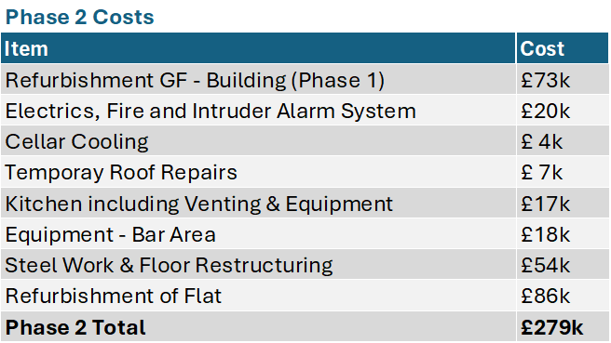

As stated above, the pub needed significant works to bring it back into operation. Unfortunately, as most of the back of house (kitchen, cellar, and upstairs toilet areas) as well as the function room had been removed, significant capital investment including a full-downstairs re-wire were required to reopen the pub.
Once the Society had acquired the building, a structural survey revealed that significant steel work was required to make the building safe, adding cost that had not been anticipated in the initial business plan. This additional cost was largely offset by savings made in the kitting out of the kitchen and cellar.
As most of the bar area was intact, the work to decorate and refurbish this part of the site was undertaken by volunteers maximising the value achieved for the members investment.
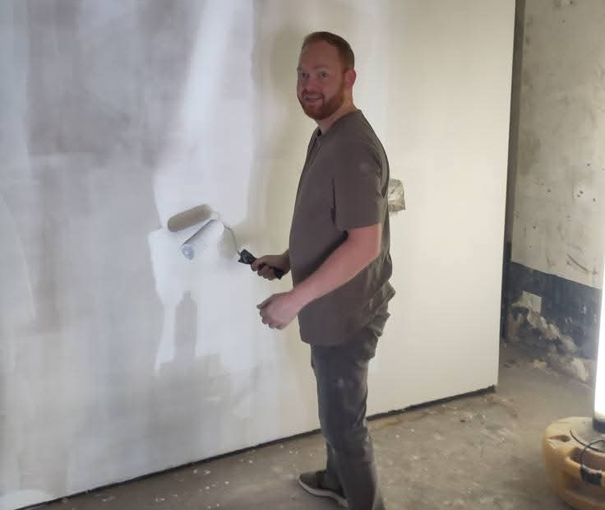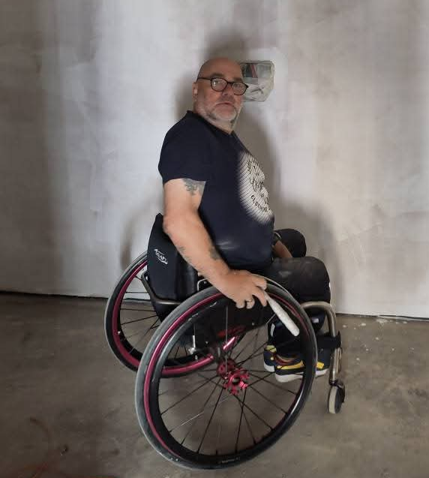
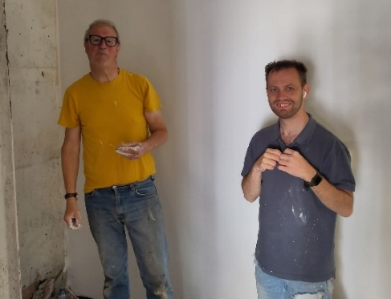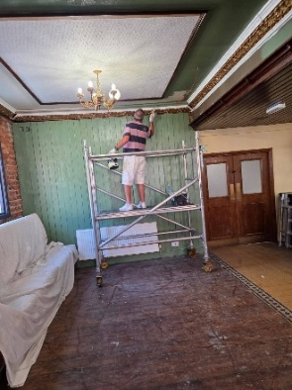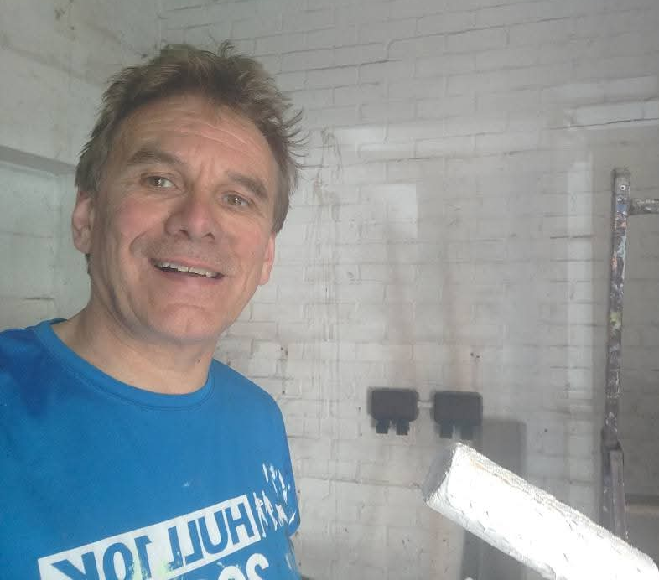
Images of committee members, volunteers and the Bar Manager volunteering with decorating the pub
Accessibility. We are committed to making The New Clarence the most accessible pub and community space in the city centre by introducing the following facilities:
- A fully accessible toilet has been installed on the ground floor
- A lift has been installed making the upstairs accessible for the first time
- A second accessible toilet will be installed upstairs to serve the function room
- The upper floor will be levelled to create step-free access

Energy Efficiency. The Hull Community Pub Society believes in the necessity to reduce carbon emissions and, as part of its membership of Oh Yes! Net Zero, has produced a carbon reduction plan. Throughout the renovations, we’ve prioritised energy efficiency and have an agreed target, signed off by the management committee, to reduce the energy to reduce the carbon footprint of the building by 50% during the renovation phase and will monitor the actual emissions from the outset. Our carbon reduction plan is available on the Society website www.hullcommunitypub.com

Sources of Funding for Phases 1 and 2
The Hull Community Pub Society was successful in a £300,000 grant bid from the Government’s Community Ownership Fund (COF) in 2024. £250,00 of this Government grant was used purchased the pub, meaning that the asset and freehold of the New Clarence is owned outright by the Society. The £50,000 revenue portion of the grant enabled us to pay for professional fees and operational costs associated with running the Society prior to the pub reopening and becoming revenue generating.
In addition to the Government funding the Society has attracted significant funding from members of the public and co-operative movement via a community share issue. The minimum shareholding offered was £100 for those with a HU postcode and £250 for those living outside the HU postcode area. We were assisted by monies from the Community Shares Booster fund via Co-operatives UK who matched the first £75,000 of donations and a further £40,000 of match funding from ICOF. We also received £10,000 of energy efficiency funding from Hull City Council, and £15,475 of energy match funding via the Crowdfunder website. This money has been used to fund the renovation of the pub.

Phase 3 – Current Project - Function Room and Future Developments
A sub-committee has been established to produce detailed plans for phase 3. The costs for phase 3 are going to be higher than the original plan because there are some unanticipated costs including:
- Replacing the roof and gutters
- The windows require significant renovation or replacement
- The function room itself is now four times as large as originally expected due to the steelwork being installed and the removal of a wall.
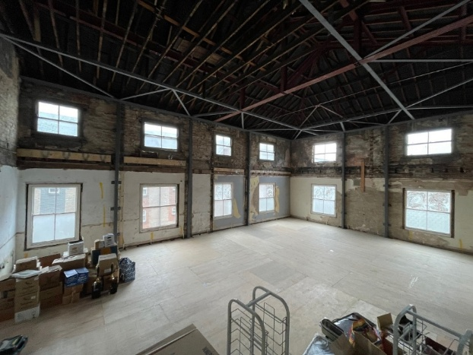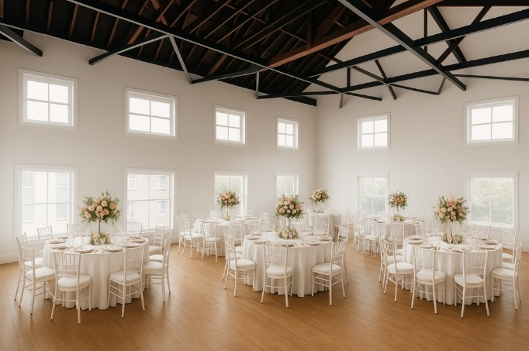
The New Clarence Function Room as is AI generated image of what it could look like

We had originally anticipated that the renovation of the function room would cost in the region of £70k. At that stage our plans for it were more modest (the function room was a quarter of the size), we hadn’t anticipated that the roof and gutters would need replacing and that the windows required attention. With the roof replacement and our more ambitious plans for the function room we now expect the cost in the region of £260k. Details of the capital plan for the function room are included in section 9.

COMMUNTIY ENGAGEMENT

About the Community
Hull has a population of approximately 260,000 people, and members of the Society come from across the city and beyond, reflecting broad community support for The New Clarence. The pub is located in the 14th most deprived ward in England, and Hull is the fourth most deprived local authority in the country. This context underlines the importance of providing accessible, affordable community space and sustainable local employment opportunities in the city centre.

A Rich History of Community Use
Before its closure, The New Clarence hosted a wide range of events that brought together people from all walks of life. These included local history nights, band performances, science talks, student music nights, comedy shows, poetry workshops, arts groups, charity meetings, fundraising events, and much more. The pub also hosted regular gatherings for groups such as the Hull and East Yorkshire adult fans of Lego, the Cricket Umpires Association, and the Tolkien Society, along with countless social events, such as weddings, birthday parties and anniversaries.
Since the pub’s closure, many of these groups have struggled to find venues that offer the same facilities and atmosphere. However, many of them are eager to return to The New Clarence. In addition to welcoming back previous regulars, we aim to attract even wider community participation. With the recent closure of four local churches and the only community centre in the area, our function room will provide an essential community space in the heart of the city.
In a community survey conducted in September 2023, we asked former patrons what The New Clarence meant to them. Commonly mentioned words included "friendly," "safe," "community," "great," and "atmosphere." One quote captured the essence of the responses:
"I used The New Clarence as a place to enjoy great food, drinks at affordable prices, and fantastic service. I listened to live music, met old friends, made new ones, learned about Hull’s history, joined a choir, and participated in Tolkien Society meetings. It was the perfect spot for pre- or post-theatre visits, where I could have conversations without loud background music. I always felt safe there, whether on my own or with friends, and my LGBTQ friends felt welcomed too. There’s no other place in Hull where I could experience all of this."

Meeting the Need
The New Clarence stands out from other city centre meeting spaces for several reasons:
- The Hull History Centre, located nearby, offers meeting spaces but is limited by opening hours and doesn’t operate in the evenings.
- Hull Central Library has restricted hours: Monday and Tuesday (closes at 5pm), Wednesday and Thursday (closes at 7.30pm), Friday (closes at 1pm), and is closed on Sundays.
- Over the last four years, four local churches and the Mitchell Community Centre (the only council-run community centre) have closed, leaving a gap in meeting spaces.
- Other local venues don’t offer the same range of food and drink options available at The New Clarence, nor will they allow people to bring in their own catering.
- There are a number of other first floor function rooms in the city centre but without lift access.

A survey conducted on our behalf by Forum (the local CVS body) in early 2025 revealed strong support from the community. Of the 40 responses, 33 organisations expressed interest in using The New Clarence for events, including:
Darts teams  Chess clubs  Cricket clubs  Tolkien Society  Parent Carer Groups  Trade Unions | Timebank  Pint of Science  Acting workshops  Hull Independent Cinema  CAMRA  Rugby teams

While some of these groups can be accommodated in the raised seating area or the downstairs meeting room, many of the groups are larger and require more space.
Since re-opening, a number of groups have already started to use the ground floor space in the pub including CAMRA, Friends of the Earth, The Tolkien Society and Co-operation Hull. We have also had people hold family occasions, retirement dos and talks in the raised area.

Community Engagement: We actively seek community engagement via surveys, members evenings, feedback forms and our Annual General Meeting.

MARKET RESEARCH

To support the social aims of the society we have done extensive market research to fully understand the commercial potential of the function room. As we are not-for-profit, we will limit the commerciality of the venue to support low-cost community usage. However, our plan demonstrates that bringing the function room back into use will create more jobs and ensure the long-term sustainability of the venue.
The city centre location and the existence of the function room in The New Clarence were included as unique features in the Asset of Community Value nomination to Hull City Council. By bringing it back into use we will be making available approximately 150 SqM of fully accessible city centre community and commercial space.

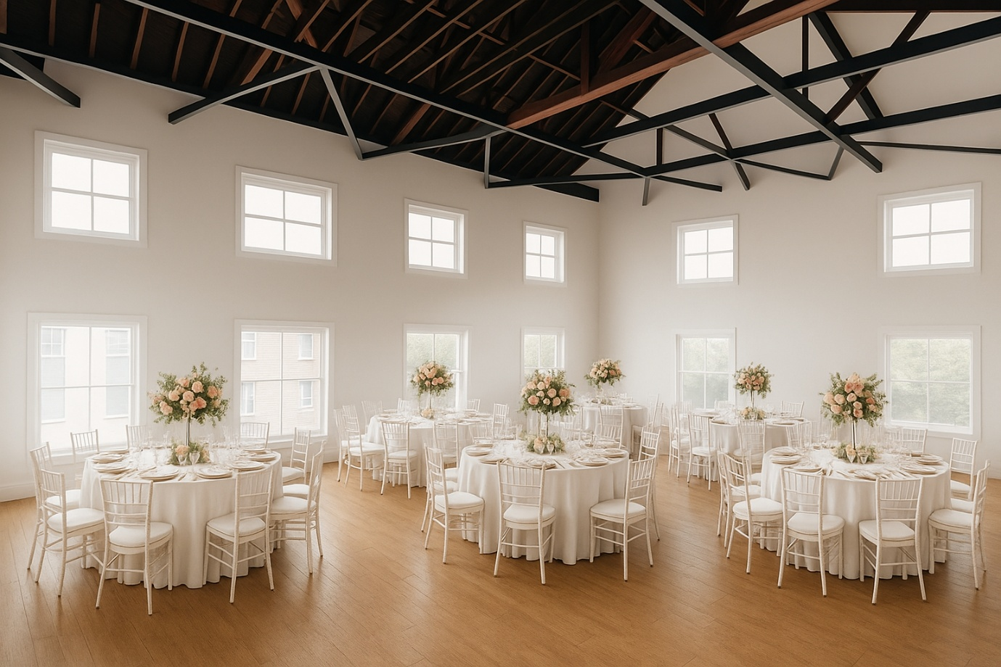
AI generated image of what the refurbished New Clarence function room could look like

Our target market for commercial activities will include:
Weddings  Conferences  Real Ale Festivals | Open Mic nights  Comedy evenings  Gigs | Birthday/Anniversary/Christmas parties  Dance lessons  Major TV Sporting Events (BBC)
The current availability of event spaces in the city centre is relatively limited, and the venues available fall into three primary pricing tiers:
Premium Segment | Mid-Range Segment | Budget Segment
The Guildhall  - Reception room hire: £300 per day  - Additional food packages available upon request  The Hilton Lexington Rooftop Bar  - Exclusive access to a designated section of the bar  - Choice of five canapé selections  - One arrival cocktail per person, with options including Cosmopolitan, Espresso Martini, or Lexington Colada  - Price: £21.50 per person  - Additional cocktail per person: £7.50  - Bottles of Prosecco: £35 per bottle, or three bottles for £95 | Kingston Theatre Hotel  - A local competitor in the wedding and events market, though with limited accessibility due to stairs both at the main entrance and to the function room  - Weekend Wedding Package: For 50 wedding breakfast guests and 75 evening guests,  Price: £4,995  - Evening Reception Package (7pm start): For 75 guests, including hot & cold buffet, room hire, chair covers, DJ and disco, wedding coordinator, a glass of wine per guest for the toast, and fresh flowers on tables  - Price: £2,195 | Maurice Rawling Community Centre (not city centre)  - Large Room/Hall: £30 per hour, £40 per hour on weekends (Saturday/Sunday)  - Small Room: £20 per hour  - Full Day Hire: £200 for the hall  - Full Day Weekend Hire: £250–£300  The University (not city centre)  - Sandwich buffet: £9.20 per person

We will position ourselves towards the mid-range for commercial activities and in the budget segment for community/non-commercial activities.

Our Venue
Our function room will be designed and certified in compliance with building regulations to accommodate up to 300 people, although the optimal working capacity for comfort is closer to 120 guests for a sit down event and 200 guests for standing events. Additionally, a separate meeting room is planned on the first floor, which could cater for meetings of 10-12 people.
We will differentiate ourselves by offering flexible event space that allows external catering, including collaborations with local businesses and food establishments. This flexibility addresses a key concern for many event hosts—budgets often limit guest lists, especially when factoring in the cost of catering.
Unlike many venues that charge £10–£20 per person for a fork buffet, we provide a comprehensive package that accommodates a variety of dietary preferences and cultural needs. Our offering for wedding/family events will include:
- Round tables with linen tablecloths
- Chairs, crockery, cutlery, and glassware
- A DJ for entertainment
- A glass of fizz (including non-alcoholic options) per person for a toast
Package Price: £1350 for up to 100 people
This approach enables hosts to tailor their catering to specific dietary needs while-ensuring a smooth event experience. Our venue's profitability is driven by drinks sales, making events a lucrative opportunity.

Indicative Cost Breakdown (for 100 people)
- DJ Fee: £350
- Table Linen Hire (10 sets): £150
- Napkins (High-Quality Paper): £50
- Prosecco (20 bottles): £500

Alternatively guests could elect to just hire the function room for c.£300 a day and source the other items directly.

Marketing and Booking Pipeline

To build a strong pipeline of bookings, we will begin a pre-booking campaign three months before the function room opens. We will work in partnership with local wedding planners and event organisers, and promote the venue through Visit Hull, social media channels and established local networks. To encourage early uptake and secure forward bookings, we will also offer introductory discounts for initial events.

THE BUSINESS PLAN FOR THE FUNCTION ROOM

Pub Trading record for year 1 (September 2025 – December 2025)
The New Clarence started trading on 2nd September, having employed our experienced landlord, Jamie Reading some months before. So far 6 jobs have been created with an average of 4.5 full time equivalent (fte) hours being worked. This has been supplemented by volunteers from within the local community and shareholder base, and during the busy December period it is envisaged that we will employ effectively 6 fte The Society has also committed to being one of the 16,000 employers nationally which pays the real living wage. This remuneration in our case also applies to all staff over 18. The one part-time staff member under 18 is paid at the National Living Wage rate for his age group.
Although it was difficult to establish prospective trading budgets for a pub that had been closed for two years, and which was being relaunched with a different focus and food offering trading exceeded projections in the first three months, with cost controls maintained within budget. This gives the Management Committee confidence in the robustness of its’ financial planning assumptions.

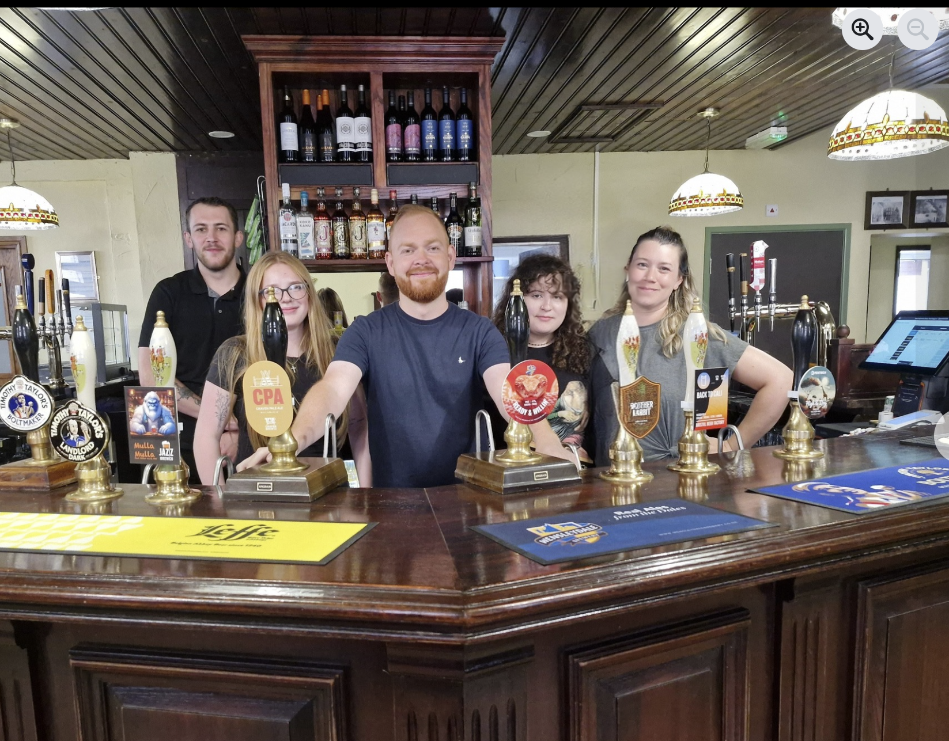
Bar Manager, Jamie Reading with the team

Financial Plans for the Function Room
With confidence that our original trading business plan proven to be accurate and coherent we can move ahead with our Function Room development. It is envisaged that this will not only drive footfall to our core pub business but will also fill a gap in the market for community groups and those seeking a fully accessible large space for rental for parties, conferences, weddings and funerals. Given the success of our existing trading figures and the accuracy of our business plan we are confident that our projections for the function space will be realised.
We also appreciate that although we are not a sport pub, with Satellite Pay-to-Air TV, many of the UK’s set-piece unifying sporting occasions, like the FA Cup, the Olympics and the Football World Cups are still mandatorily on terrestrial TV. As such this function room facility would lend itself for events linked to use of this space for booking or groups.
Additionally, we know that had the space been available a recent CAMRA beer festival would have been held at our city-centre location. We would envisage a range of festivals, supplemented by booked events like wine tastings would also utilise this space

Projected Additional Income
Rental - It is envisaged that the Function Room would generate an additional income of at least £50,000 per annum, from stand-alone rentals, and functions. The going rate for room rental would be £250-£300 for the day, without any additional income from food and drink sales. It is assumed that a weekend private function or party would bring in an additional income of £500-£1000 per event.
We believe that given the demand and requests already received for bookings for private parties, that the projected £1000 a week for room rental and income is realistic and achievable.
Footfall uplift to core business - Although it is difficult to quantify and to model, it is inevitable that the additional footfall generated from parties, conferences, and meetings would lead to an uplift for the main core business and make it more likely to exceed its budgeted targets. This will be for two principal reasons: -
- Venue Awareness – Attendees will be more aware of the location of The New Clarence and be more likely to re-attend a venue they have an awareness of.

- Staying Put - Other venues report that a proportion of attendees often stay at locations after the end of formal events, or if they are arriving earlier than timetabled “do’s”, particularly conferences and funerals, if there is a licensed premise on site. We would be well-placed to benefit from this knock-on trade.

Projected Additional Outgoings
Energy We have assumed that the additional rental space would require additional energy costs. As this would only be incurred if the facility was let, this is a co-dependent cost against income, and not a fixed liability. The amounts included in the financial plan for energy are linked to the number of events and the time of year.
Staffing As some rental would be “room only” the additional staffing costs would be variable, but this model assumes that it would lead to 2-3 additional part-staff, supplemented by additional staff brought into service events. This would be an additional staff cost of £30k or £2.5k per month on average.
Loan Repayments As the wider-business model of the pub has been established to service the loan/borrowing to support the renovations there would not be an additional cost to service the borrowing from the income from the function room.
Initial outlay in order to be able to cater for sit down events £2,727
- 10 Circular Tables £1,259
- 100 Chairs £945
- 110 Sets of Cutlery £249
- 11 Tablecloths £175
- 100 Champagne Glasses £97
The costs mentioned in this section are reflected in the profit and loss forecast included in Section 10.

THE CAPITAL PLAN

We stated earlier that the refurbished function room space could cost in the region of £260,000, with plans still being worked on. This is not speculative but based upon a suite of costed quotes already received. We are seeking 3 quotes from a principal builder for the majority of the work there will be additional specialist works required such as a sound system and the construction of a bar area for the upstairs. There are also variable costs for the roof replacement and the replacement/repair of the windows. Additionally, some elements of costs such as the Accessibility Toilet are non-negotiables given the driving ethos and stated aims of the Society.
With a successful share issue and the allocation of a grant from Hull City Council, elements of the work could start by the summer of 2026, and we could ensure that trading of the upstairs space could commence before Christmas.
Funding Strategy and Conditionality

The Society’s strategy is to secure as much non-share funding as possible before drawing on community investment. We have applied for £130k from Hull City Council. The proposed share issue is designed to:
- Demonstrate community backing to strengthen our grant applications;
- Unlock match funding opportunities;
- Provide us with the opportunity to commence the work on the function room even if the grant application is unsuccessful.

The minimum share raise of £10k has been set to ensure that we have sufficient funds to replace the gutters and roof. Any amounts raised over and above the minimum will enable us to progress with later stages of the renovation plans.

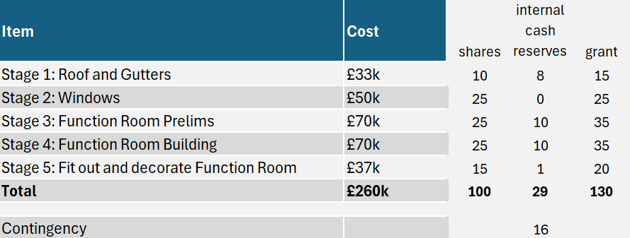

If we fail to raise £10k all money raised will be returned to individuals. If we hit the minimum £10k target we will have enough money to undertake stage 1 and undertake the work to the roof and gutters. Any additional share funds raised over and above the £10k minimum will be kept by the Society in a separate bank account and will be put towards the later stages set out in the table above as and when the match funding is achieved.
Share Offer: We have notified members of the plans for the function room and the intention to do another share offer via email and have sought feedback from them. The response has been positive. The additional shares will be made available to members first and any remaining shares can be purchased by non-members. The Society has recently received confirmation from HMRC that members who purchased a large number of shares in the first share offer are eligible to claim back 50% of the amount invested from the first share issue under the SEIS scheme. As there is no change to the business model, we expect investment made into this new offer will be eligible to claim back 30% of the value of shares purchased in the new offer under the EIS scheme. People investing above £1000 may therefore be able to reduce their income tax liability by 30% of whatever they invest (and if they use funds that represent a taxable capital gain to make the investment, they can also reduce the CGT due until such point as the shares are withdrawn). We wll apply for EIS certificates once the share offer is concluded
Hull City Council Grant: The Society is the process of applying for up to £130k of grant funding from the Council with some documentation outstanding at the time of finalising the business case. The outcome should be known in the early summer of 2026, before works on the building are carried out. The Councils Grant funding works on the basis that the recipient match funds the grant. The works are paid for by the recipient and 50% can then be claimed back. So, if we are successful the Society will have to pay for works in advance and then claim 50% back from the Council. Achieving the £100k upper share target by July will greatly assist in enabling the works to the function room to progress.
Internal Cash Reserves and Loans. The Society currently has £45k of cash reserves. It took out £80k of borrowing from directors/members loans in August 2025 of which £69k is outstanding in the balance sheet. A £100k loan (7% over 120 months with a charge on the building) has been secured from CCF which the plan assumes will be received in May 2026. It was originally anticipated that this loan would be received in the summer of 2025 and when it became apparent that it would take longer the directors/members loans were made. £69k of the CCF loan will be used to pay back the bridging loans made by directors/members of the Society in August 2025 in June 2026. The remaining £31k of the CCF loan will, alongside £26k of existing short term borrowing from one of the directors at 6% per annum, be used to provide cash flow support through the construction phase. Due to the nature of the Hull City Council Grant the Society must first pay all of its invoices including VAT and then be reimbursed by the Council after payment of the invoices. We anticipate that the £26k directors loan will be cleared by February 2027 from VAT reimbursements and Council Grant Reimbursements.

Financial Forecasts

Profit and Loss Forecast (Pub + Function Room)
Function Room Assumptions:
- 1-2 events per month increasing to 7 in December for all years
- Interest on all shares paid at 3% from 2029 onwards
- 3% inflation assumed for all costs per year
- Energy linked to number of events and time of year
- Staff cost linked to functions (63%)
- Cost of sales linked to functions (30%)

Cash Flow Forecast

Assumptions:
- 7.5% withdrawal of capital projected from 2029
- Assumes maximum share purchase of £100,000 achieved

Balance Sheet Forecast

Note that the outstanding £69,326 loan amount will be paid off when the £100,000 CCF loan is received. The £26k loan that appears in the above table will be paid back once all VAT has been reclaimed on the works.

key risks and mitigations

Risk | Likelihood 1-3 | Impact 1-3 | Combined score  1-9 | Mitigation | Post Mitigation Likelihood  1-3 | Post Mitigation Impact  1-3 | Combined score  1-9 | Comments
Hull City Council unsuccessful | Medium | High | 6 | Phased development + alternative grants | Medium | Low | 2 | The work which is fundable will be done, and the work which can’t yet be funded will become our capital development plan and monitored on an ongoing basis.
Lack of interest in community shares | Medium | High | 6 | Strong marketing to existing members and marketing campaign to recruit new members and promote tax relief | Low | High | 3 | Strong marketing to existing members and marketing campaign to recruit new members
Lower than projected bookings | Medium | Medium | 4 | Pre-opening marketing campaign | Low | Medium | 2 | In addition, we already have visibility of existing demand from enquiries we have received which are not able to be met at present.
Construction cost inflation | Medium | High | 6 | Fixed-price contracts | Low | High | 3 | Fixed-price contracts

