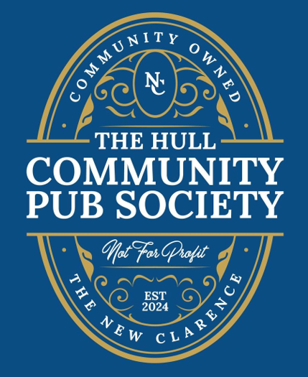 | Chairperson’s Report 2024  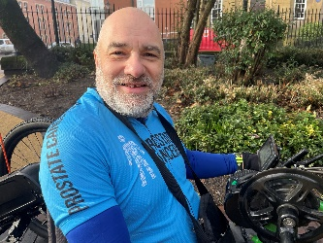

Introduction
This year, we have achieved something truly extraordinary. The Hull Community Pub Society has proven that communities can come together to make a difference. According to a report by Plunkett UK, a charity supporting community businesses, only one in twelve rural communities manage to save their pubs, with the chances being even slimmer in urban areas. Yet, here in Hull, we have defied the odds.
The New Clarence is officially designated as an Asset of Community Value along with the Setting Dyke Community Green Space and the KC Stadium, it is the only ACV pub in Hull. After the owners initiated the moratorium period, we managed to raise over £450,000 through shares and grants. This achievement allowed us to purchase the pub, and we now have enough funding to begin renovations.
Our vision is to make The New Clarence a welcoming and accessible space for all. This includes installing a lift to the function room and renovating the toilets. We are also exploring opportunities to make the building carbon-neutral by investing in the latest sustainable technologies.
After this AGM on 1 March, we will relaunch our share offer to recruit new members and raise further funds, ensuring we can fully realise our vision for The New Clarence.

About the Hull Community Pub Society
The Hull Community Pub Society was formed with a single, vital purpose: to save The New Clarence pub so that it can continue to be an inclusive community space for all. Since its inception, our Society has grown to include over 300 members. I want to extend my heartfelt thanks to all our members for joining us on this journey.
Hull has a proud history of co-operative ventures, and we are excited to contribute to the revival of this spirit of collaboration. Our committee members have worked tirelessly to make this dream a reality over the past year and a half, and I extend my deepest gratitude to them for their dedication and hard work.

Activities Undertaken by the Society in 2024
This has been a pivotal year for our Society, marked by significant milestones:
- Formation of the Society
- Development of a robust business case
- Successful application for a £300k Community Ownership Fund (COF) grant
- Meeting the lower target for our share issue of £150k (the upper target is £250k)
- Negotiating the purchase of The New Clarence pub.
These accomplishments are a testament to the collective efforts of our members, committee, and supporters.

Thank You to our Funders and Supporters
We are incredibly grateful for the support and funding we have received from Plunket UK, Co-Operative and Mutual Solutions, Forum, Co-Operatives UK, Power to Change, Community Shares Booster Fund, HM Government

 | 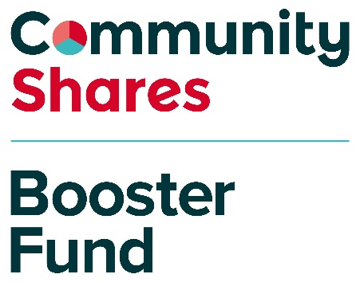
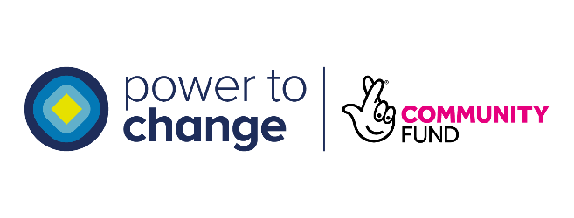
 | 


Further Fundraising
A number of grants have become available to us and we will be working on applications for those over the coming months.
We have also decided to reopen the share issue for the following reasons:
- Now that we own the building we think there will be a lot of positivity around the project which gives us an opportunity to recruit new members and supporters.

- We only just got the keys to the building and are revisiting all the costs. Some are higher than expected and some are lower. So generating additional capital gives us some resilience if the costs end up being higher than expected.

- We have the offer of the loan finance but will be less reliant on that if the share sales get to the maximum and if we are successful in some of the new grants we are submitting.

Update on Finances
The original business plan and share offer laid a solid foundation for our financial strategy. Thanks to our members and grant funding, we have not only secured the pub but also ensured we have the resources to start renovations.

Capital for the Purchase and the Renovations
Some of the costs and sources of funding are different to what was included in the original plan and we want to draw members attention to some of the larger variations. In particular we agreed to make an additional payment of £50k to the owners of the building at the point they sold it to us. Some of the costs are higher than we anticipated, for example we may have to pay c. £10k to remove asbestos from the building. We have also managed to secure the option of a £100k loan which we could draw down on if we do not hit our new fundraising targets.
The following tables show the original capital plan and the ones beneath show the updated figures.
Please note that the capital profile is still being worked on and is subject to further change as fundraising progresses and costings for the renovations are firmed up.
The 2024 Accounts
The draft income and expenditure accounts are showing a deficit of £7,249 for the year ending 31 December 2024. The reasons for there being a deficit in the accounts is as follows:
- We paid £4,021 in crowd funder fees for the shares sold. The share income from the crowdfunder site appears in the balance sheet (£76,252 cash at bank and in hand and in the £155,350 members capital) but the fees are reported in the income and expenditure account.
- The draft accounts include a £1,000 assumption for Corporation Tax. Our accountants are checking this and the figure made reduce in the final version of the accounts.
- The fees for the accountants to prepare the accounts is included in the 2024 figures, even thought the spend took place in February 2025. This is standard accounting practice.
The other spend that took place up to December 31 2024 included professional advice on our business plan and the community share issue, planning costs and marketing and events costs associated with the share issue. We received a £10,000 grant from the Community Shares Booster fund and we also raised £1,659 via gofundme. The grant and fundraising covered all of these costs.
Although the COF grant of £300k was announced in March 2024 we did not draw down the funding until we had confirmation of the completion date which was in February 2025, which was after the 31 December 2024 reporting date for the 2024 accounts. The COF grant will therefore be reported in the 2025 accounts.

Governance
Our Society has grown to include 307 members, a remarkable achievement. Currently, the committee consists of seven dedicated individuals. To further strengthen our governance, we are seeking to increase committee membership to nine.
We will continue to hold our AGM annually as well as periodic general meetings. We are keen to hear members' views on how frequently additional meetings should be held to foster engagement and transparency.

Looking Forward to 2025
The coming year promises to be just as exciting and transformative. Our priorities include:
- Fundraising: Relaunching our share offer to attract new members and raise the funds needed to complete our renovations.
- Renovating the Pub: Bringing our vision of a fully accessible and sustainable New Clarence to life.
- Community Involvement: Encouraging members and supporters to get involved in various aspects of our project. Whether through fundraising, volunteering, or simply spreading the word, every contribution helps.

History of The New Clarence
The New Clarence has a rich and fascinating history. The original Clarence pub, which stood on the other side of Charles Street, was demolished in the late 1980s. Both the original Clarence and the site of The New Clarence appear in the background of the market scene in the 1985 "Only Fools and Horses" Christmas special, To Hull and Back. |  | 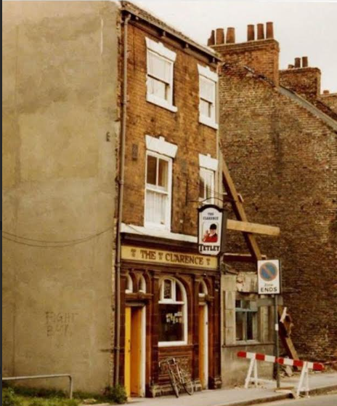
The New Clarence is not a traditional street-corner pub. It comprises four buildings—10 John Street and 77, 78, and 79 Charles Street—believed to have been built in the 1850s. Initially, the Charles Street buildings housed shops on the ground floor with flats above. During the First World War, these buildings were converted into a Co-operative grocery store. After the store’s closure in the 1960s, the buildings served as meeting and education rooms for the Co-operative Society until the 1980s.

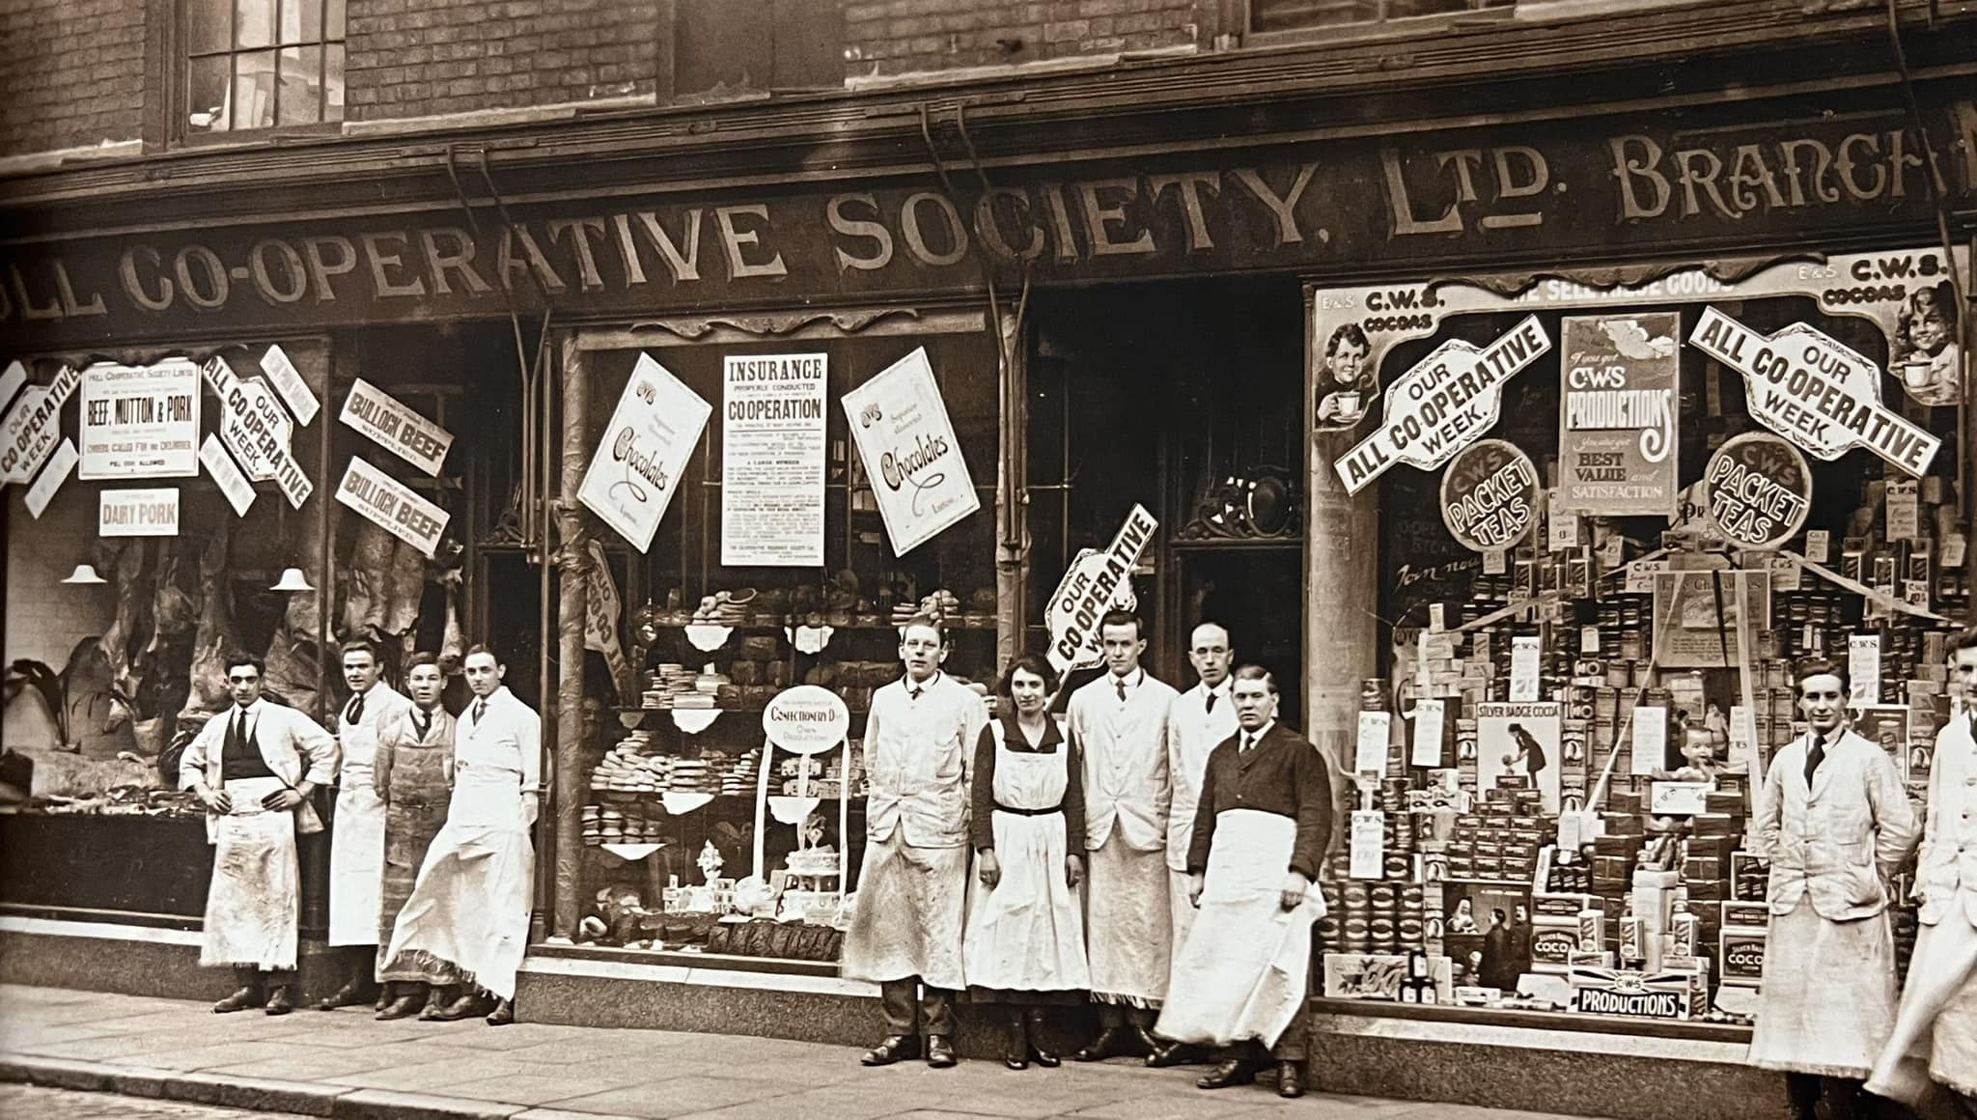
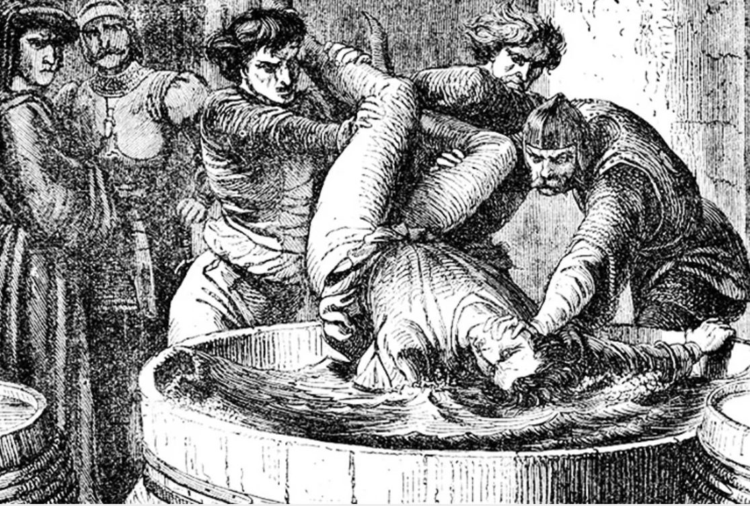 | In 1989, the building was converted into a pub following the demolition of the original Clarence. Interestingly, The New Clarence is the only pub with this name. Its predecessor was named after the Duke of Clarence, the brother of Richard III, who was executed for treason. Legend has it that as a royal, he was allowed to choose the manner of his execution and opted to be drowned in a barrel of Madeira wine.

Thank you to everyone who has been part of this incredible journey so far. Together, we are not just saving a pub; we are creating a vibrant, sustainable community hub that will serve Hull for generations to come.
Simon Berry PLY, Chairperson, 13 February 2025

